2nd Annual School Safety Training Conference

February 20th – 23rd 2023
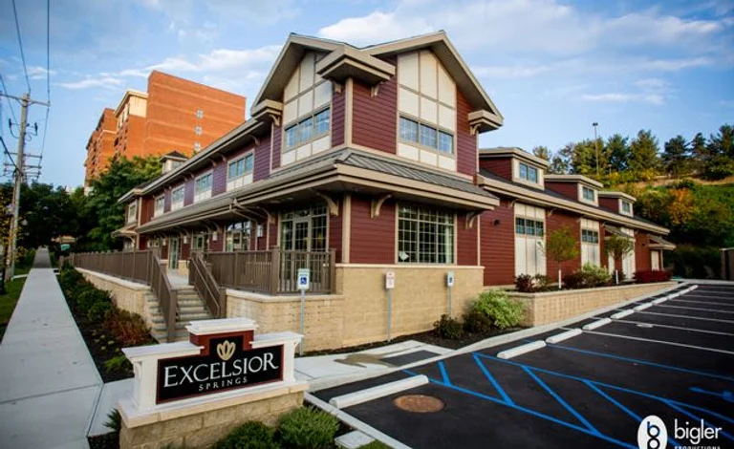
Excelsior Springs Event Center
11 Excelsior Ave Saratoga Springs, NY 12866

Conference Agenda
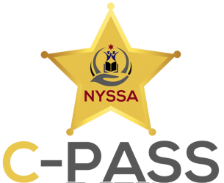

The Committee on Policing and Safeguarding Schools (C-PASS) understands that protecting students is an ever-changing task and one of the upmost importance. The committee constantly strives to identify new issues and develop training to meet those needs faced not only by school resources officers but all those involved in the school community. Since the committee is not bound by a single state agency, or under any state mandate, C-PASS can be flexible and swift in tackling new school issues. We have been successful thus far in all of our endeavors by understanding the importance of collaboration, because in the end we are always
BETTER TOGETHER.

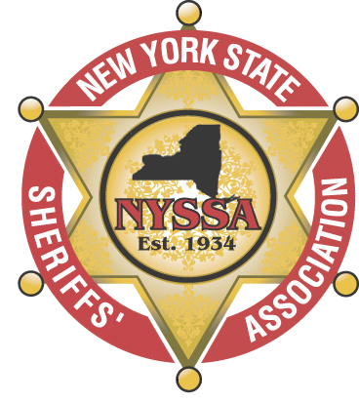

C-PASS School Safety Training Conference Schedule

February 19th 2023
16:00 – 21:00 Registration Begins – Hotel Lobby

February 20th 2023
07:00 – 08:00 Registration (Event Center Lobby) - Coffee & Refreshments
08:00 – 08:30 Opening Ceremonies – Jonathan Becker/C-PASS Director, Albany County Sheriff Craig Apple/2023 NYSSA President, Saratoga County Sheriff Michael Zurlo, Lt. Eric Warfield/Saratoga Springs Police Department, Steuben County Undersheriff John McNelis/C-PASS Chairman, Deputy-SRO Robert Holt/Livingston County
08:30 – 09:00 School Safety Communications Solutions, FirstNet with Intrada – Marie Farrell, Daniel Willingham (FirstNet); Richard Darnell, Brian Toolan (Intrado)
09:00 – 12:00 Mass Shootings in Schools: Lessons from Tragedy and Opportunities for Prevention and Response – Dr. Jaclyn Schildkraut
12:00 – 13:00 Lunch (Sponsored by FirstNet built by AT&T)
13:00 – 15:00 Arapahoe High Debrief – Deputy James Englert – Colorado
15:00 – 16:00 LGBTQIA+ Sensitivity Training – SSS Vernon House NYPD
16:00 – 16:30 Daily Debrief

February 21st 2023
07:00 – 08:00 Coffee & Refreshments
08:00 – 10:00 Bullying and Crisis Prevention – Dr. Amanda Nickerson – University of Buffalo
10:00 – 12:00 CSTAG/Threat Assessment – Dr. Dewey Cornell – University of Virginia
12:00 – 13:00 Lunch
13:00 – 16:00 Threat Assessment – The National Threat Assessment Center – United State Secret Service
16:00 – 16:30 Daily Debrief
18:00 – 22:00 Networking Dinner and Live Music – Excelsior Center (Sponsored by Rapid Responder)

February 22nd 2023

07:00 – 0:800 Coffee and Refreshments
08:00 – 12:00 Standard Reunification Method Workshop – Dan Rector, MS, CEM – I Love U Guys
12:00 – 13:00 Lunch
13:00 – 16:00 Post-Traumatic Stress Disorder, to protect and serve those that protect and serve – Cattaraugus County Sheriff Timothy Whitcomb (Sponsored by NYSSA’s Health & Wellness Program and FirstNet built by AT&T)
16:00 – 16:30 Daily Debrief

February 23rd 2023

07:00 – 0:800 Coffee and Refreshments
08:00 – 11:45 The lessons learned from the lives lost, The Uvalde Debrief – Tom Czyz, CEO – Armoured One
11:45 – 12:00 Closing and Farewell

THANK YOU TO OUR CORPORATE PARTNERS
AND EVENT SPONSORS

Diamond Corporate Partner
&
Monday Lunch Sponsor
FirstNet is the only nationwide, high-speed broadband communications platform dedicated to and purpose-built for America's first responders and the extended public safety community.

Marie Farrell, FirstNet Manager for Update New York
MF3290@att.com
315-830-4994
https://www.firstnet.com
https://www.intrado.com
Gold Corporate Partner

Day Automation is a leading provider of unified security solutions, building automation, network infrastructure and energy services. Our innovative solutions provide secure, comfortable, connected and sustainable environments for our clients.

Founded in 1976, the company has grown to be one of the premier security and building automation solution providers in New York State. We bring smart, reliable solutions to provide a safe and secure environment for our clients.

Day Automation provides services that impact over a half million students in over 285 school districts, colleges and universities. We also provide solutions to industrial, commercial and institutional clients, including hospitals, libraries, and government offices, helping control the cost of energy and facility operations. Our systems are installed in 1500+ buildings across New York State.

For more than 40 years Day Automation has worked with clients to deliver customized solutions that exceed current and long-term goals. Our customer focused service and delivery models and Our “Customer for Life” philosophy drive every part of our business to pledge high value service and commitment to success.

Richie Perna, Chief Strategy Officer
Richie.perna@dayautomation.com
917-214-3273
https://dayautomation.com

Tuesday Night Networking Dinner Sponsor

Rapid Responder is the most widely deployed all-hazards school crisis management system in the United States, protecting thousands of campuses across the country. The process results in an enhanced community-wide joint response to any type of emergency. The program includes the Easy Alert App which is a communications tool for emergencies and other incidents at your facility. Prepare your teams to collaborate and communicate during any type of emergency (medical, natural disaster, active shooter, etc.). You can notify, chat, share images, and report GPS locations. Access emergency plans and critical facility information from Rapid Responder. This is very helpful to first responders when responding to an emergency at your school district. Be prepared with the Easy Alert App!

For other questions or more information about Rapid Responder or Easy Alert please contact:

James Bowers, Program Manager
jbowers@nysheriffs.org
518-669-1279

Make sure to visit all of our vendors
during breaks!!!

Buffalo Armory LLC
Day Automation
FARO
Federal Eastern International
FirstNet Built with AT&T
Linstar
Marist College
Mutualink
National Child Safety Council
NYS Department of Labor – PESH Bureau
NYS Industries for the Disabled
Rapid Responder
Soter Technologies LLC
ZOLL Medical Corporation

Thank you to all of our Exhibitors!

